**HALF SUBTRACTOR**

**EXP NO.2:**

AIM: To show the working of half subtractor using logisim.

Truth table:

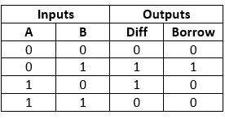

OUTPUT:

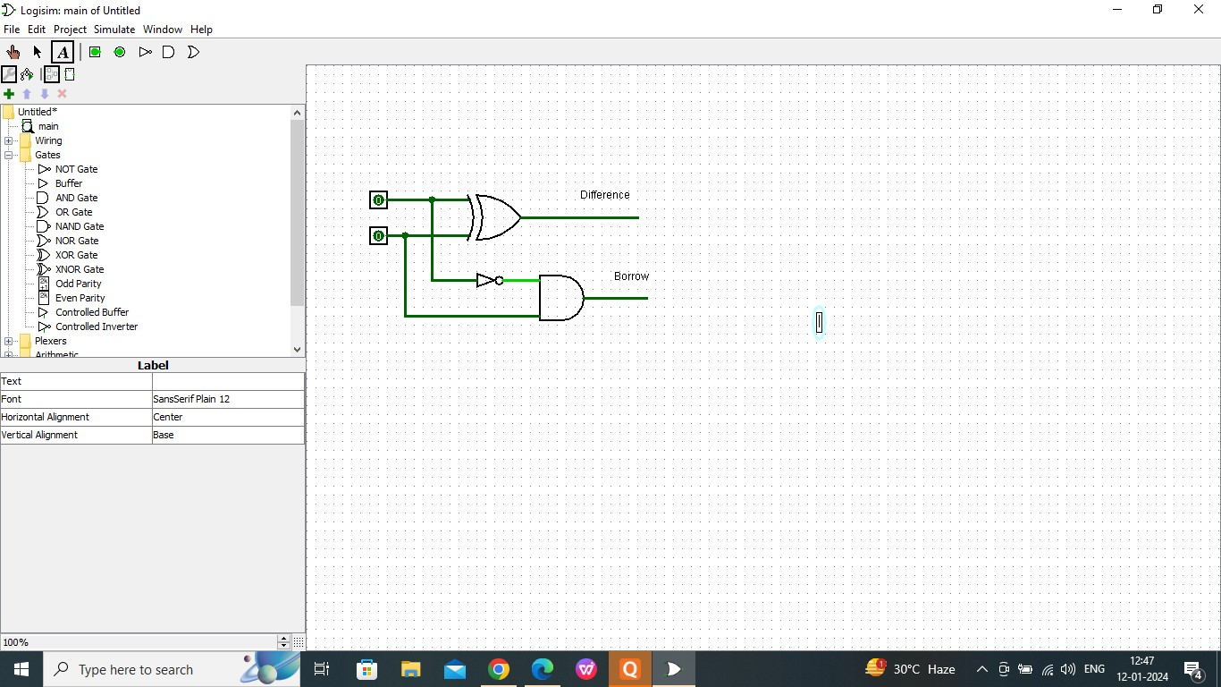

RESULT:

Thus the working of half subtractor has been observed successfully using logisim